Tremolo
12AX7
243 vdc
121 vdc
8
7
6
124 vdc

9
5
470K
6.3 vac

4
1
3
2
121 vdc
1.2 vdc

* All voltages were taken with the Tremolo turned OFF *
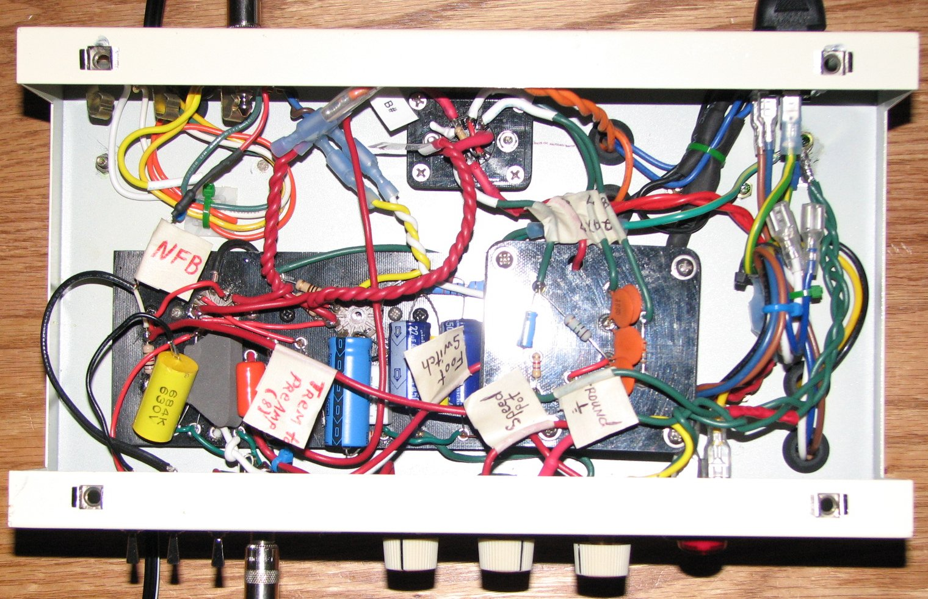
PreAmp
12AX7
Power
EL84
9
3
4
5
6
7
8
2
1
9
5
4
3
2
1
6
7
8
C3 (Switchable)
Tremolo
Add on
Circuit Board

300 vdc

185 vdc
1.54 vdc
269 vdc

6.3 vac
6.3 vac

1.58 vdc
185 vdc
9.85 vdc

